30 sep

Seminar introduction to fashion

For blog - (favourite fashion designer)

Issey Miyake

Japanese brands are always has been a part of my inspirations after experiencing and. As I would like to have a concept and a vision taken from bits of the Japanese culture and vibes thus Issey Miyake pleats please really stood out for me in terms of its value and the experiments, issey miyake pleate please is more joyful and has a soul to it. specially how colourful some of the campaign looks.
To describe it, the pattern is so well- put together. Issey Miyake was experimental with the designing as well as innovative and when it comes to technology, I always seek for festinating technology combination, and Issey Miyake was the one.
Personally, the prints are so fun to look at
it is all about the art and fashion combined. And its movement of its cloths and its connection with body and how it is flexible for every body type that Issey Miyake did through his career.
the first impression that I have received from this brand was how cloths for this brand really meant to be free and flattering on body

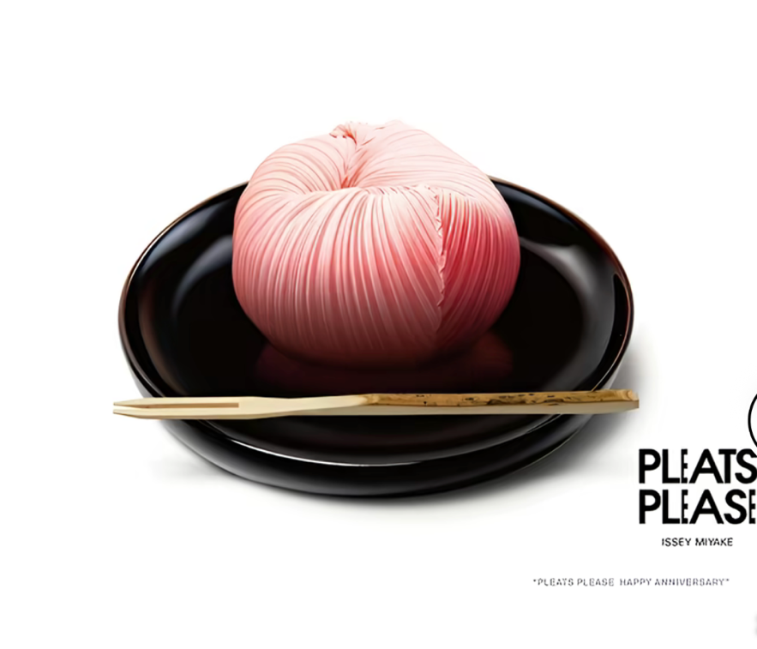
Wagashi

in addition, looking and observing the campaign’s comes first and there were several campaign’s that matched my style. Particularly which I mentioned of recent admiration of the concept of food and fashion. Principally, I am more looking forward to seeing connection with cloths like this was the only campaign that got me into Issey Miyake which was the Taku Satoh ad campaign for Issey Miyake for their 20th anniversary (2012)
my first though of this campaign was how flattering and adaptive the movement feels in these photos.

As I seen gen z’s are beginning to buy and collect archives and vintage cloths Issey Miyake was one of the brands that I saw so many prints of it that were considered rare items which showed how the gen z or other groups of age found a connection with story behinds the please pleats collections in my own view the prints are so fun to look at, there are so many experiments and patterns to explore and search for which I was motivated to go deep down into the history of the prints to mention one that I saw in an exhibition called ‘ dirty looks ‘ the art piece was experimented with fire which was memorable.

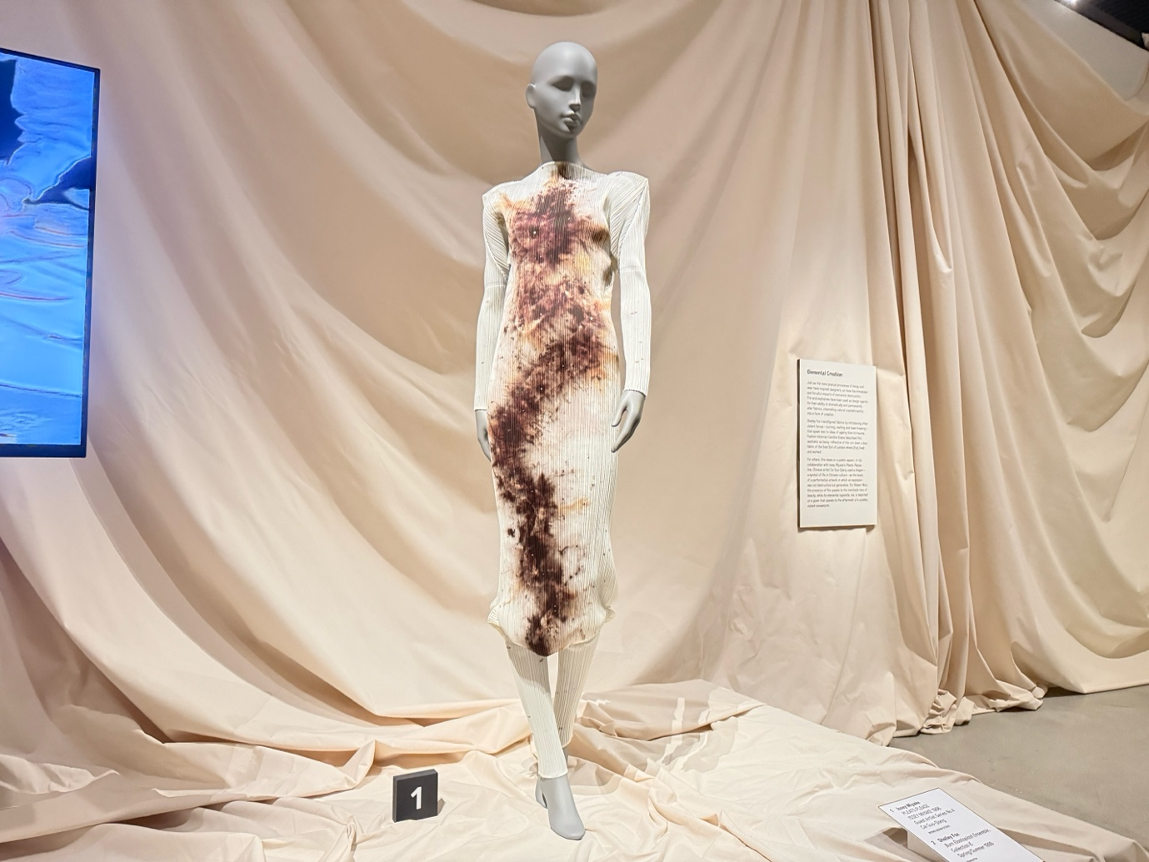
‘Dirty looks’ exhibition in London

there are so many experiments and patterns to explore but out of all pleatse pleatse was the one who I was motivated to go deep down into the history

mainly history and the art was not the only thing that made me more carious about this brand but the photography
was part of it.
To name one of the most noteworthy and unforgettable collaboration is Irving Penn an American photographer who took so many futuristic photos for Issey Miyake.

